Newton’s 3rd Law
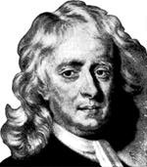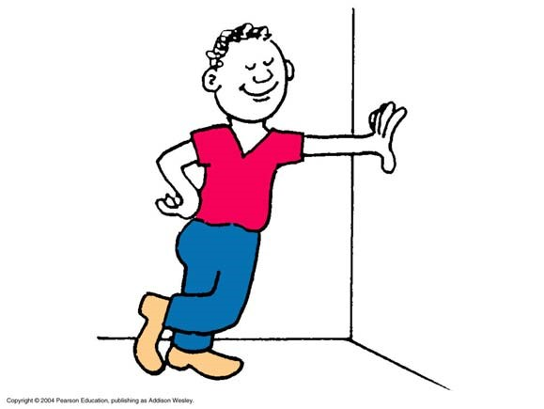
^{F}hand on wall =−^{F}wall on hand
To every force there is an equal but opposite reaction force.

Newton’s 3rd Law
^{F}hand on wall =−^{F}wall on hand
You can’t TOUCH without being TOUCHED back!!
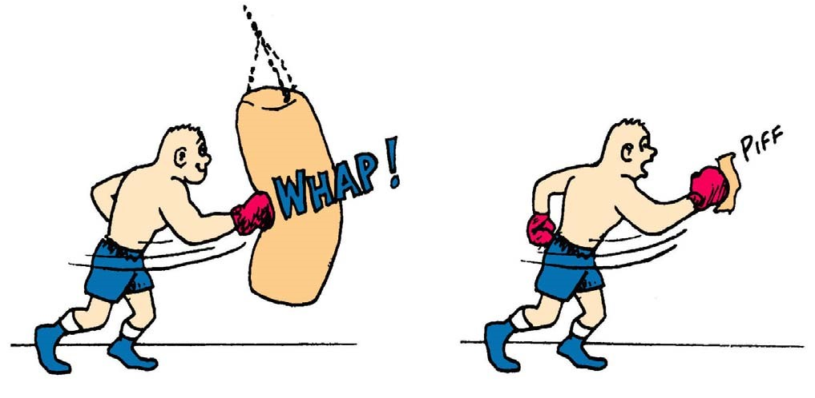
An interaction requires a pair of forces acting on two objects.

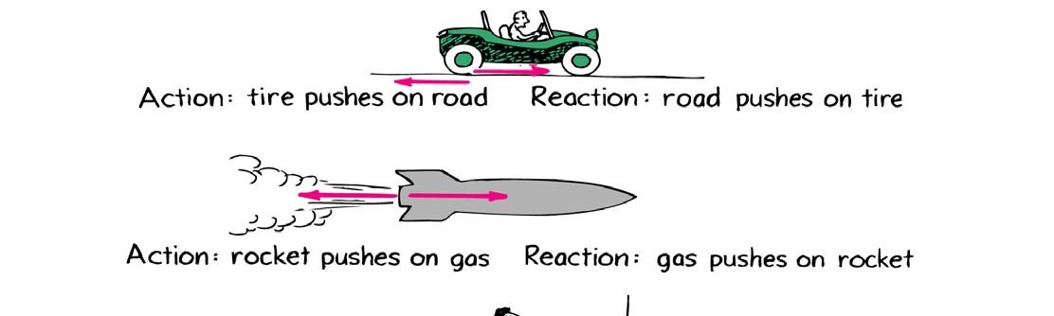
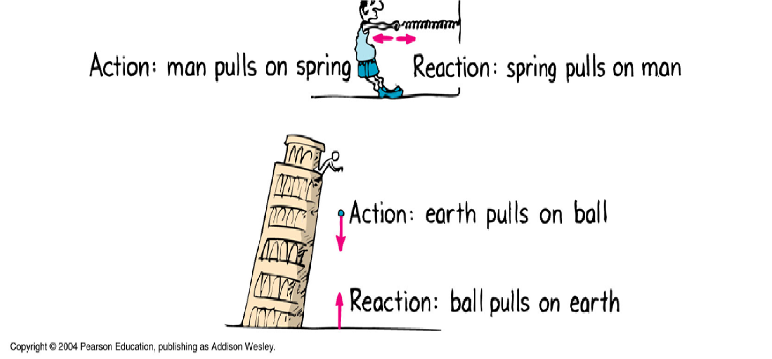
Action-Reaction Pairs
If ACTION is A acting on B, then REACTION is B acting on A.

Bug Splat
A bug and bus have a head on collision.
Compared to the FORCE that acts on the bug, how much force acts on the bus?
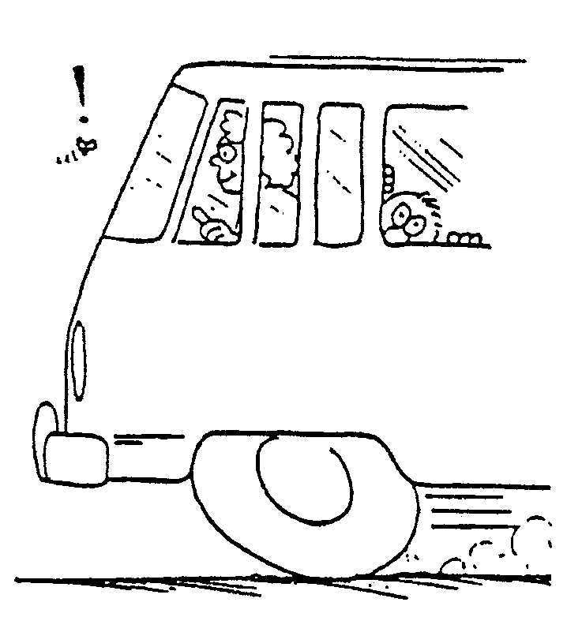
More Same Less
Newton’s 3rd Law: for every force there is an equal and opposite force
Fon the bus =−Fon the bug

Bug Splat
Which undergoes the greater acceleration?

Bug Splat
Which undergoes the greater acceleration?
Bug Same Bus
This is because the mass of the bug is so small. The force (F), divided by a tiny mass (m) means the acceleration (a) will be large.
a= F
m

Which suffers the greatest damage?
Bug Same Bus
The mass of the bus is very large. The same force (F), divided by a very large mass (m) means the acceleration (a) will be tiny, and no-one on the bus even notices it slow down a tiny bit because it collided with the bug. The bug notices it however!!!!!

Action-Reaction Pairs
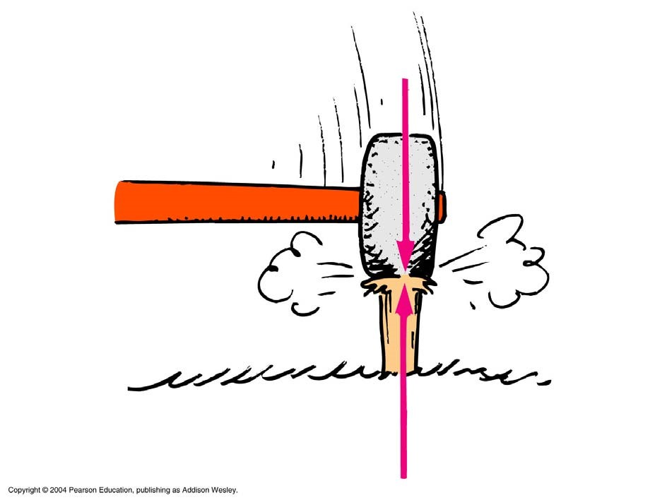

Action-Reaction

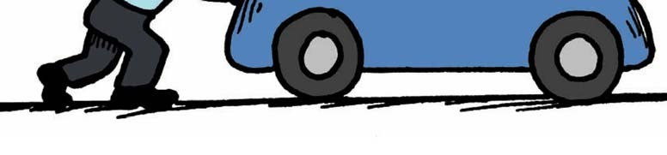
You push a heavy car by hand. The car, in turn, pushes back with an opposite but equal force on you. Doesn’t this mean the forces cancel one another, making acceleration impossible? Why or Why not?

When Action-Reaction pairs act on different objects, the objects likely have different masses and other forces (friction) acting on them.
In the example above the man pushes on the car, which (according to Newton’s law, pushes back equally). Because the man has less mass he is the most likely to move. However if he leans in and increases his frictional force, the car will move because it has less frictional forces stopping it from moving.

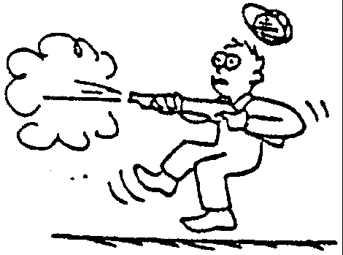
Action Reaction Pairs
kick

Gun Pushes Bullet out.
Bullet Pushes back on Gun (& Man)
Same force, bullet accelerates fast (low mass), human accelerates slowly (high mass)

Rocket Thrust
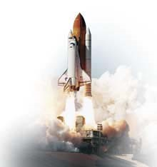
Rocket Pushes Gas Out.
Gas Pushes Back on Rocket.

Same force, air accelerates fast (air has low mass so it accelerates quickly), rocket accelerates slowly (high mass

Newton’s 3rd Law
^{F}hand on wall =−^{F}wall on hand
This is an INTERACTIVE Universe.

